Q.1 Write a program to replace a substring inside a string with other string ?

import java.util.Scanner;

public class Main
{
public static void main (String[]args)
{
String sentance, al_string;
Scanner e = new Scanner (System.in);

System.out.println ("Enter a string : ");
sentance = e.nextLine ();

System.out.println ("Now enter a string to replace with : ");
al_string = e.nextLine ();

System.out.println ("Orignal string : " + sentance);
System.out.println ("New string : " +
sentance.replace("sandeep",al_string));
}
}

Output:
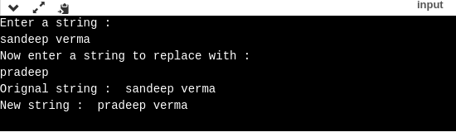

Without inbuilt function:

import java.util.Scanner;

public class Main
{
public static void main (String[]args)
{
String sentance, new_string,replace_with;
String match_with = "verma";
Scanner e = new Scanner (System.in);

System.out.println ("Enter a string : ");
sentance = e.nextLine ();

System.out.println ("Now enter a string to replace with : ");
replace_with = e.nextLine ();

int position =sentance.indexOf(match_with);
int len = match_with.length();

new_string = sentance.substring(0, position) + replace_with + sentance.substring(position+len);
System.out.println(new_string);

}
}

Output:
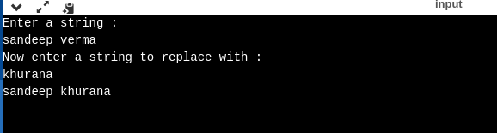

Q2. Write a program to find the number of occurrences of the duplicate words in a string and print them ?
package com.company;

public class Main {

public static void main(String[] args) {
String str = " this is is the word this is this";
int count;
String duplicates="";
String[] words = str.toLowerCase().trim().split(" ");
for(int i=0;i<words.length;i++)
{
count=1;
for(int j=i+1;j<words.length;j++)
{

if(words[i].equals(words[j]))
{

count++;
}
}

if(count>1)
{
if(duplicates.isEmpty()) {

duplicates +=" "+ words[i] + " : "+ count ;
}
else if(!duplicates.matches("(.*) "+words[i]+" (.*)"))
{

duplicates +=" "+ words[i] + " : "+ count;
}

}
}
System.out.println(duplicates);
}
}

Output:

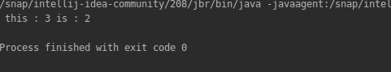

Q3. Write a program to find the number of occurrences of a character in a string without using loop?

class A {
String str;
int len;
int count;
char c;
char ch[];
A()
{
count = 0;
str = "sandeep";
c = 'e';
ch = str.toCharArray();
len = str.length();
}
int call_me(int len) {

if (len < 1) // base case
{
return count;
}
else if(ch[len] == c)
{
++count;
}

return call_me(len-1);
}
}
public class Main {

public static void main(String[] args) {
A obj = new A();
System.out.println(obj.c+" occurred in "+obj.str+ " :"+obj.call_me(obj.len-1));

}
}

Output:
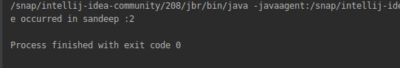

Q4. Calculate the number & Percentage Of Lowercase Letters,Uppercase Letters, Digits And Other Special Characters In A String
public class Main {

public static void main(String[] args) {
String str = "tH@";

int count_lower=0,count_upper=0,count_special=0;
char[] ch = str.toCharArray();
int len = ch.length;
for(int i=0;i<ch.length;i++)
{
if( Character.isLowerCase(ch[i]))
{
++count_lower;

}
else if(Character.isUpperCase(ch[i]))
{
++count_upper;

}
else if(!Character.isDigit(ch[i])){
++count_special;
}

}

System.out.println("In string "+ str+" \n Percentage of lowercase : "+((count_lower*100)/len) +
"%\n Percentage of Uppercase : "+((count_upper*100)/len)+
"%\nPercentage of Special Charactor : "+((count_special*100)/len)+"%");

}
}

Output:
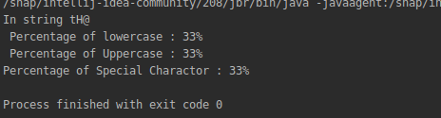

Q5. Find common elements between two arrays.

package com.company;

public class Main {

public static void main(String[] args) {
int[] arr = new int[]{12,1,2,3,1,2};
int[] arr2 = new int[]{1,2,4,5,3};
String c;
int len_arr1 = arr.length;
String common_elements ="";
boolean flag;
int len_arr2 = arr2.length;
for(int i = 0; i<len_arr1;i++)
{
flag =false;
for(int j=0;j<len_arr2;j++){
if(arr[i]==arr2[j])
{

flag =true;
break;
}

}
if(flag)
{
c = " "+arr[i]+" ";
if(common_elements.isEmpty())
common_elements += " "+arr[i]+" ";
else if (!common_elements.matches("(.*)"+c+"(.*)"))
{
common_elements += " "+arr[i]+" ";

}

}
}

System.out.println("These are repeated values in both arrays : "+common_elements);

}
}

Output:

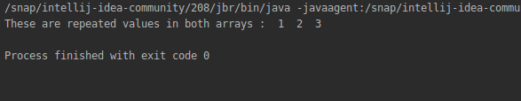

Q6. There is an array with every element repeated twice except one. Find that element
public class Main {

public static void main(String[] args) {
int[] arr = new int[]{6,6,3,7,2,3,2,1};
int count;
boolean flag = false;
for(int i=0;i<arr.length;i++)
{
count = 1;
for(int j=0;j<arr.length;j++)
{
if(arr[i] == arr[j] && (i !=j))
{
++count;
break;
}
}
if(count==1) {
flag = true;

System.out.println(arr[i]);
}

}
if(flag == false)
System.out.println("Nothing is unqiue");

}

}
Output
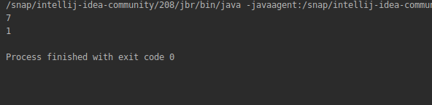

Q7. Write a program to print your Firstname,LastName & age using static block,static method & static variable respectively

class person {
static String FirstName ;
static String LastName;
static int age;
int x;
static{
FirstName = "Sandeep";
LastName = "Verma";
age = 22;

}
static void display()
{

System.out.println("First Name : "+FirstName+"\n Last Name : "+LastName+"\n Age :"+age);
}
}
public class Main {

public static void main(String[] args) {
person obj = new person();
obj.display();
}
}

Output:
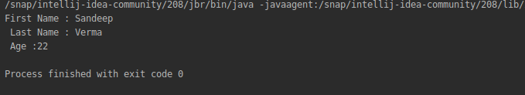

Q8. Write a program to reverse a string and remove character from index 4 to index 9 from the reversed string using String Buffer

public class Main {

public static void main(String[] args) {
StringBuffer str = new StringBuffer("Sandeep Verma ");
str.reverse();
System.out.println("After reversing : "+ str);
str.delete(4,9);
System.out.println("After deletion : "+ str);
}
}

Output:
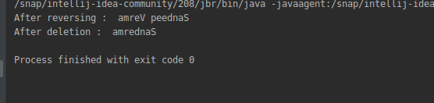

Q9.Write a program to display values of enums using a constructor & getPrice() method (Example display house & their prices)
package com.company;

enum house_info{
HOUSE1("House 1", "Rs. 8lakh "),
HOUSE2("House 2", "Rs. 7lakh "),
HOUSE3("House 3", "Rs. 10lakh ");
private final String HOUSE_NAME;
private final String HOUSE_PRICE;

house_info (String house, String price)
{
this.HOUSE_NAME = house;
this.HOUSE_PRICE = price;

}

String getHouse()
{
return this.HOUSE_NAME;
}
String getPice()
{
return this.HOUSE_PRICE;
}

}

public class Main {

public static void main(String[] args) {

System.out.println("Name of House : "+house_info.HOUSE1.getHouse()+" \n Price of House : "+house_info.HOUSE1.getPice());

}
}

Output:
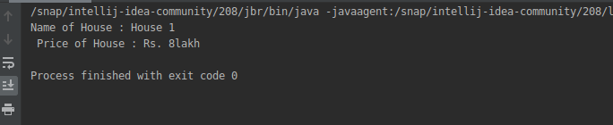

Q10.Write a single program for following operation using overloading
A) Adding 2 integer number
B) Adding 2 double
C) multiplying 2 float
D) multiplying 2 int
E) concate 2 string
F) Concate 3 String
package com.company;

public class Main {

int add (int a,int b)
{
return a+b;
}
float add (float a,float b)
{
return a+b;
}
int multiply(int a,int b)
{
return a*b;
}
float multiply(float a,float b)
{
return a*b;
}

String concate(String a,String b)
{
return a+b;
}
String concate(String a,String b,String c)
{
return a+b+c;
}

public static void main(String[] args) {
Main obj = new Main();
System.out.println( "Add Int : "+obj.add(6,10));
System.out.println( "Add Float : " +obj.add(6.6f,10.5f));
System.out.println( "Multiply Int : "+obj.multiply(6,10));
System.out.println( "Multiply Float : "+ obj.multiply(6.6f,10.5f));
System.out.println( "Concate two : "+obj.concate("Sandeep"," Verma"));
System.out.println( "Concate Three :"+ obj.concate("Sandeep"," Verma", "\n JUst on another line"));

}
}

Output:
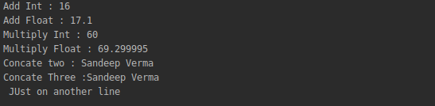

Q11.Create 3 sub class of bank SBI,BOI,ICICI all 4 should have method called getDetails which provide there specific details like rateofinterest etc,print details of every banks
package com.company;

class Banks {

class ICICI {
int rateofinterest;
String name;
ICICI()
{
rateofinterest = 10;
name = "ICICI";
}

int getDetailsIneterest()
{
return this.rateofinterest;
}
String getDetailsName()
{
return this.name;
}
void print(int rate, String name)
{

System.out.println(" Bank Name : "+name+"\n Rate of Interest : "+rate);

}

}

class SBI {
int rateofinterest;
String name;
SBI()
{
rateofinterest = 11;
name = "SBI";
}
int getDetailsIneterest()
{
return this.rateofinterest;
}
String getDetailsName()
{
return this.name;
}

void print(int rate, String name)
{

System.out.println(" Bank Name : "+name+"\n Rate of Interest : "+rate);

}

}

class BOI {
int rateofinterest;
String name;
BOI()
{
rateofinterest = 9;
name = "BOI";
}
int getDetailsIneterest()
{
return this.rateofinterest;
}
String getDetailsName()
{
return this.name;
}
void print(int rate, String name)
{

System.out.println(" Bank Name : "+name+"\n Rate of Interest : "+rate);

}

}
}
public class Main {

public static void main(String[] args) {
Banks.BOI boi = new Banks().new BOI();
Banks.ICICI icici = new Banks().new ICICI();
Banks.SBI sbi = new Banks().new SBI();
boi.print(boi.getDetailsIneterest(),boi.getDetailsName());
icici.print(icici.getDetailsIneterest(),icici.getDetailsName());
sbi.print(sbi.getDetailsIneterest(),sbi.getDetailsName());

}
}

Output:

